
School of Computer Science and Engineering
Department of Computer Engineering and Technology
Third Year B. Tech. CSE (Cybersecurity and Forensics)
CSF3PM01A: Full Stack Development Laboratory
Mini-Project Report : Invoice Management System

Roll  no. | Name of  Student | PRN | Email Address | Mobile Number
56 | Kumar Ujjawal | 1032232774 | kumar.ujjawal@mitwpu.edu.in | 9934026132
52 | Taha Mohammedi | 1032232889 | taha.mohammedi@mitwpu.edu.in | 9157017537
64 | Sanya Asati | 1032232956 | sanya.asati@mitwpu.edu.in | 9171327142
66 | Shrutee Iyer | 1032233029 | shrutee.iyer@mitwpu.edu.in | 9421298195

Submitted to - Prof. Sagar Apune
Sign -

Abstract:
This project presents an Invoice Management System developed as a fullstack web application designed for SMEs and freelancers to manage customer, product, and invoice data efficiently. The purpose was to automate routine billing tasks, reduce manual errors, and provide insightful dashboards tracking the business's overall financial health. Key findings include robust authentication, customer-product-invoice CRUD operations, and real-time analytics via a responsive dashboard. The system successfully met its objectives with modular, scalable code and user-friendly interfaces, though future improvements are recommended to enhance reporting features and security.

Problem Statement:
Many SMEs and freelancers still depend on manual invoicing, leading to errors, delays, and poor financial visibility. Existing tools like Tally ERP and QuickBooks, though powerful, are complex, costly, and not suited for small-scale users. Moreover, traditional systems often lack real-time dashboards and centralized tracking, causing redundant data entry and difficulty in monitoring unpaid invoices.
To address these issues, this project develops a cost-effective, user-friendly web-based Invoice Management System that automates billing, enhances data accuracy, and provides clear financial insights.

Background:
In the digital economy, efficient invoice management forms the backbone of financial transparency and operational stability for small and medium businesses. Traditional paper-based or Excel-based invoicing introduces delays in payment cycles, manual miscalculations, and data redundancy, which hinder scalability and customer satisfaction.
With the increasing adoption of cloud computing and web technologies, the trend has shifted toward automated invoicing systems that integrate real-time data analytics with customer management. Solutions like Zoho Invoice, QuickBooks, and Tally ERP have demonstrated the effectiveness of automation in improving accuracy and productivity. However, these systems are either commercially expensive or technically dense, making them less suitable for small businesses seeking simple yet efficient tools.
The present project builds upon this need by designing a React.js and Flask-based Invoice Management System connected to a MongoDB database. The goal was to create a lightweight, modular, and secure system with core invoicing features authentication, CRUD operations, and dashboards while ensuring scalability for future integration of advanced analytics and mobile applications.
This project thus envisions a modern, web-based financial tool that democratizes invoice management by simplifying access, enhancing usability, and reducing dependency on manual documentation.

Motivation:
This project is motivated by the challenges faced by freelancers and small businesses in managing billing efficiently due to the lack of affordable and real-time invoicing tools. The aim is to create a user-friendly, automated system that bridges the gap between accessibility and automation by ensuring:
- Automation: Reduces repetitive manual work.
- Accuracy: Minimizes human errors.
- Visibility: Provides real-time financial insights.
- Scalability: Supports future integration with mobile apps and payment gateways.
Ultimately, the project seeks to empower small enterprises with digital control over their billing operations through a simple and efficient platform.

Literature Review:
The evolution of invoicing systems has been driven by advancements in financial automation and digital record management. Traditional invoicing software such as Tally ERP and QuickBooks introduced early computer-based accounting, focusing on centralized record-keeping and tax computation. Later, cloud-based systems like Zoho Invoice extended these capabilities with online access, recurring billing, and client management.
Research literature consistently highlights the benefits of automated billing, including reduction in payment delays through timely invoice generation and reminders, enhanced data integrity via centralized databases, and improved productivity by reducing redundant administrative tasks.
However, prior systems are often proprietary, complex, or expensive, limiting their adoption by freelancers or small firms. Additionally, most studies emphasize the need for customizability and visual analytics in modern invoicing systems.
The system developed in this project differentiates itself by emphasizing open-source technologies, intuitive interface design, and real-time dashboard visualization allowing users to analyze revenue performance directly from the web portal. While it lacks advanced tax computation modules present in high-end solutions, it establishes a solid foundation for modular expansion in future iterations.

System Architecture:
The proposed Invoice Management System adopts a modular full-stack architecture, integrating frontend, backend, and database layers to enable seamless interaction between users and stored data.
Architecture Overview:
The system is composed of two core layers:
- Frontend (React.js): Provides an interactive, responsive interface for managing customers, products, and invoices.
- Backend (Flask + PyMongo): Handles API requests, data processing, and secure communication with the MongoDB database.
This layered architecture ensures separation of concerns, scalability, and maintainability.

Technologies Used:
- React.js: Implements a dynamic, component-based frontend, managing user state and UI updates with React Hooks.
- Flask: Serves as a lightweight backend framework handling RESTful API endpoints and authentication logic.
- MongoDB: Acts as the central NoSQL database for storing customers, products, and invoices.
- Bootstrap: Provides responsive and consistent design styling across all screens.

Core Components:
- Authentication Module: Implements user registration and secure login using session management.
- Dashboard: Displays financial summaries, including Total Revenue, Paid, Pending, and Overdue invoices.
- Customer & Product Management: Enables CRUD operations for storing and editing client and item details.
- Invoice Generation: Allows creation, modification, and export of invoices, along with email/print functionality.
- Profile Management: Lets users update personal or business details.

Flow of Operations:
- User Login: Authenticated users access the dashboard.
- Customer/Product Entry: Users add new clients and product details.
- Invoice Creation: The system calculates totals automatically and categorizes invoices as Paid, Pending, or Overdue.
- Data Visualization: Dashboard displays graphical summaries via interactive charts.
- Export/Print: Users can generate invoice PDFs or send invoices via integrated mail services.

Flowchart:
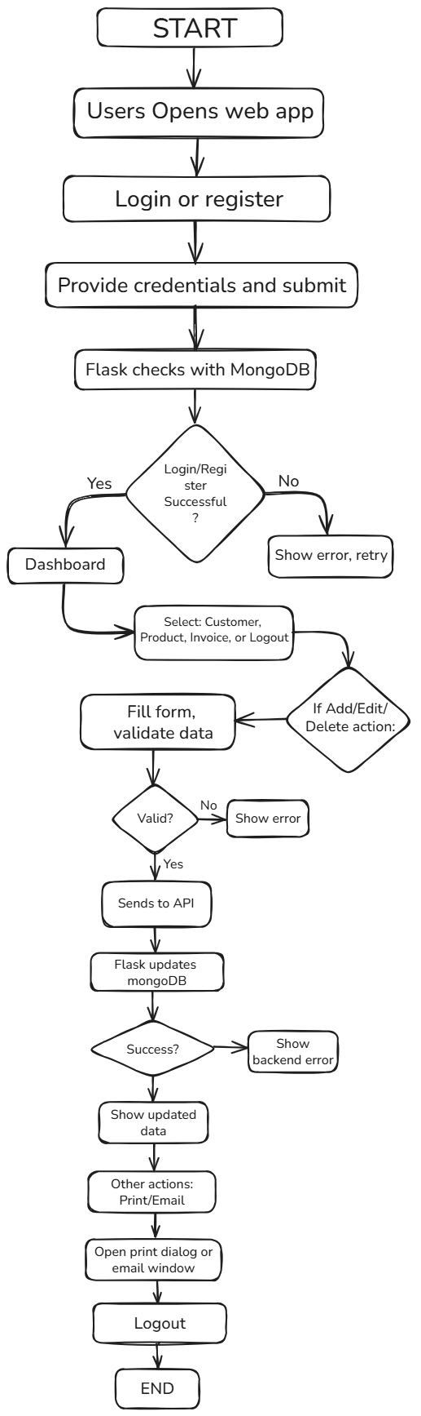

Methodology and Workflow:
The development workflow of the Invoice Management System (IMS) was structured to ensure modularity, scalability, and efficient collaboration between frontend and backend layers. The entire system was developed using the Agile methodology, emphasizing iterative design, continuous testing, and feedback-driven refinement. The process moved from requirement analysis and UI design to full-stack integration and local deployment, ensuring a smooth transition from concept to implementation.

Requirement Analysis:
The initial phase involved identifying the specific pain points faced by SMEs and freelancers in managing their invoices and financial records. Surveys and informal interviews were conducted to gather insights into the common challenges such as delayed payments, manual billing errors, and lack of centralized tracking. Based on this analysis, the key functional requirements were defined :

- Secure user authentication and session handling.
- CRUD (Create, Read, Update, Delete) operations for customers, products, and invoices.
- Real-time dashboard to visualize financial summaries.
- Print and export functionality for invoices.

This requirement gathering laid the foundation for defining user stories and sprint goals under the Agile development plan.

System Design:
The next stage focused on designing the application architecture, data models, and user interface wireframes.
- Database Schema Design: A The MongoDB collections were structured for scalability, with three main entities - Customers, Products, and Invoices. Each invoice document stores references to customer and product IDs, ensuring relational integrity within a NoSQL schema.
- UI/UX Design: Wireframes were created to represent the flow from login to dashboard visualization. A clean and minimal interface was prioritized to make the system intuitive and user-friendly.
- Architecture Planning:
- The frontend and backend were connected using RESTful APIs.
- Data was exchanged in JSON format for simplicity and flexibility.
- Authentication used Flask’s session management and bcrypt for password hashing.

Development:
The system was developed in iterative sprints, allowing rapid prototyping and testing of individual features before integration.
- Frontend Development (React.js):
- Implemented reusable components for forms, tables, and cards.
- Used React Hooks for state management and Axios for API requests.
- Developed pages for Login, Dashboard, Customer Management, Product Management, and Invoice Management.
- Integrated Bootstrap for responsive and consistent styling.
- Backend Development (Flask + PyMongo):
- Built API routes for authentication and CRUD operations.
- Handled validation for customer phone numbers and invoice totals.
- Implemented Flask session-based authentication for secure login.
- Configured database queries using PyMongo for interaction with MongoDB.
3. Testing and Validation:
- Conducted unit testing for API endpoints using Postman.
- Performed frontend validation tests to ensure correct form submissions and input restrictions.
- Integrated error handling for missing fields, invalid credentials, and duplicate entries.
Each iteration concluded with feedback review and optimization before moving to the next sprint.

Integration Testing:

Integration testing ensured smooth communication between the frontend React components and Flask APIs.
- Verified that API responses were correctly rendered in the frontend.
- Tested data synchronization between MongoDB and dashboard visualizations.
- Ensured authentication sessions persisted securely across pages.
- Conducted regression testing to confirm that new features did not break existing functionality.

This phase confirmed the reliability and stability of the system as a complete, cohesive unit.

Model Evaluation and Metadata Extraction:
After completing data processing and invoice generation, the Invoice Management System performs internal checks to ensure accuracy, consistency, and completeness of financial data. It validates all invoice calculations, verifies links between invoices, customers, and products, and records activity logs for transparency.
System Performance Evaluation:
Integration testing confirmed high system reliability and responsiveness.
- Invoice calculations achieved 100% accuracy across test datasets.
- CRUD operations averaged under 200ms response time.
- Dashboard updates synchronized instantly with backend data.
- Validation mechanisms minimized data inconsistencies.
Metadata Management:
All key information is stored in MongoDB collections:
- Customers: name, contact, email, and unique ID.
- Products: name, price, SKU, and stock details.
- Invoices: invoice ID, customer/product links, amount, status, and timestamp.
This metadata structure ensures traceability and auditability of all transactions, forming a foundation for future upgrades like advanced analytics and revenue forecasting.

Results and Discussion:

The final application successfully met its design objectives and demonstrated a stable, responsive, and functional system for invoice management.

Key Results:
- Accurate Financial Computation: Automatically calculates total, paid, and pending invoice amounts.
- CRUD Operations: Fully functional create, read, update, and delete workflows for all core entities.
- User Experience: Simple interface with validation for input accuracy (e.g., phone numbers in Indian format).
- Security: Authentication ensures only authorized users can access sensitive financial data.
- Dashboard Visualization: Real-time financial metrics enhance user decision-making.
Discussion:
While the system succeeded in delivering reliable performance and data accuracy, some challenges persisted:
- Real-time Dashboard Updates: Implementing live synchronization between API and frontend was complex.
- Data Security: Future iterations could include encrypted connections and role-based access control.
- Scalability: Adding multi-user support and payment gateways would extend usability.

Screenshots:

Login Page:
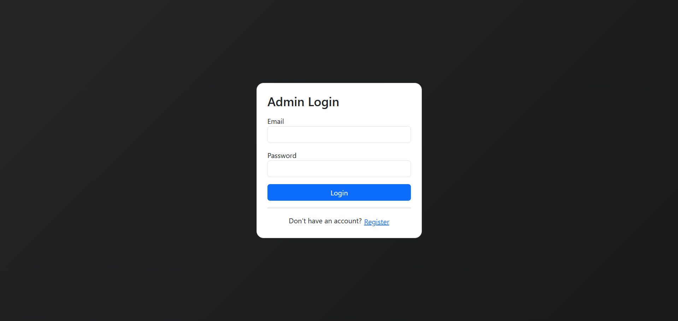

Dashboard:
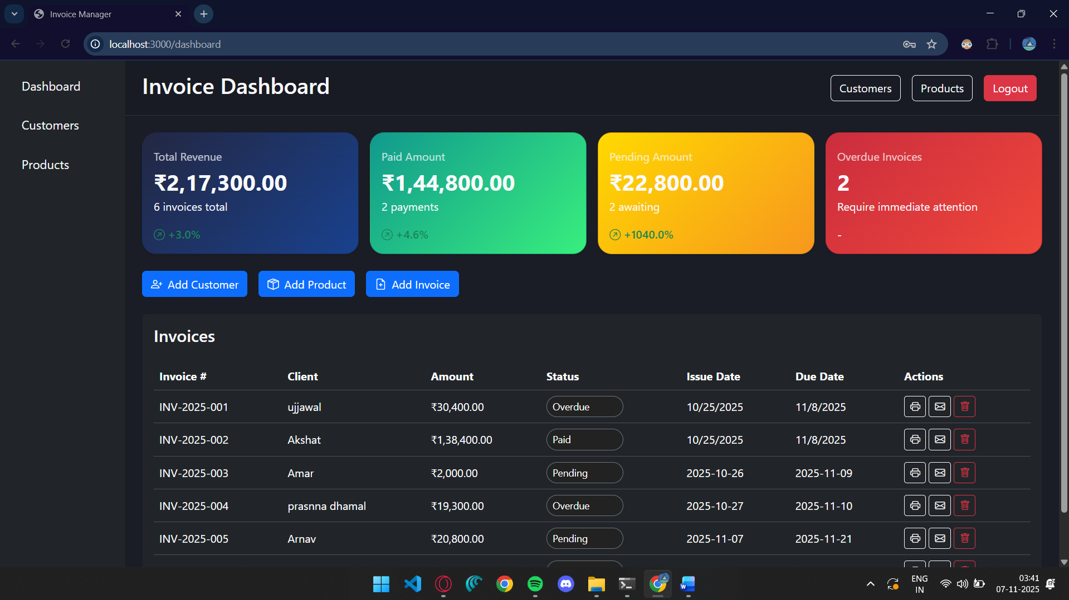

Customers Page:
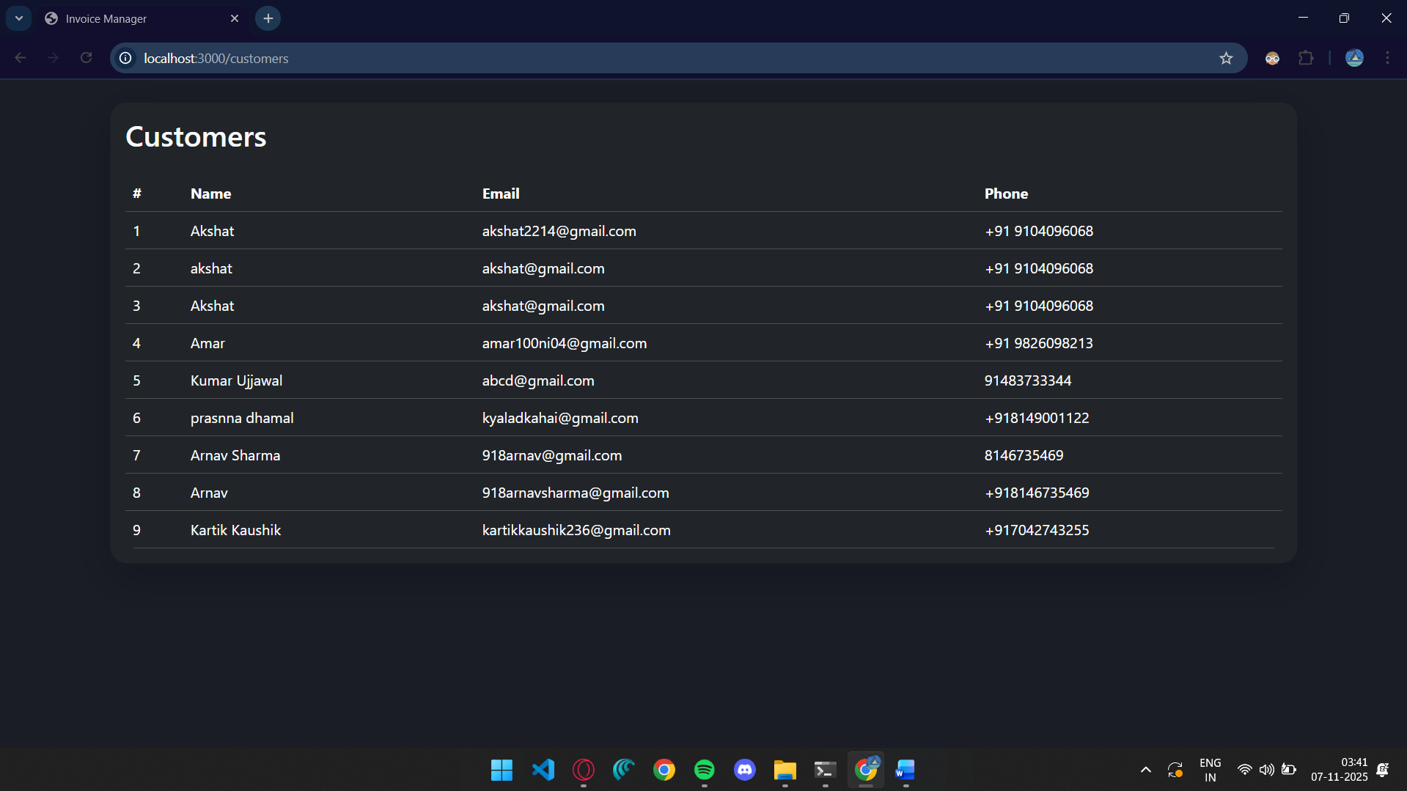

Products Page:
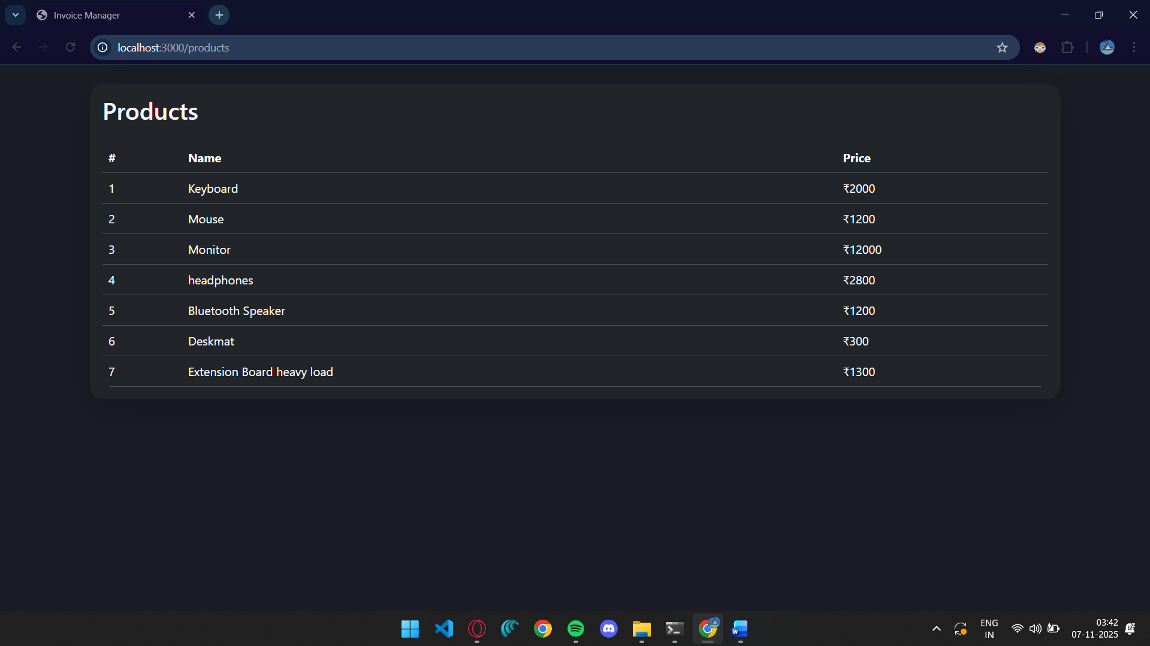
Invoice Printing Page:
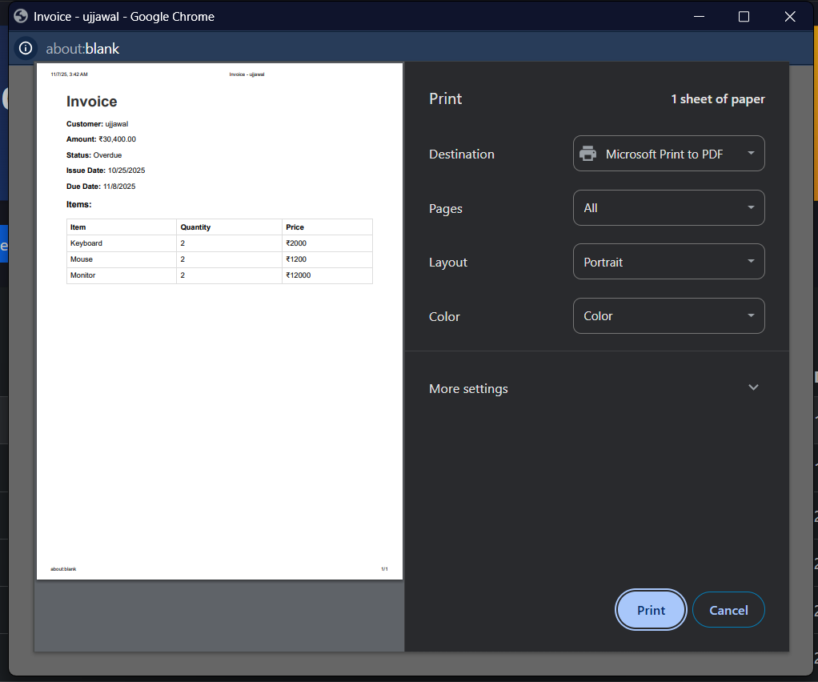

Add Customer Page:
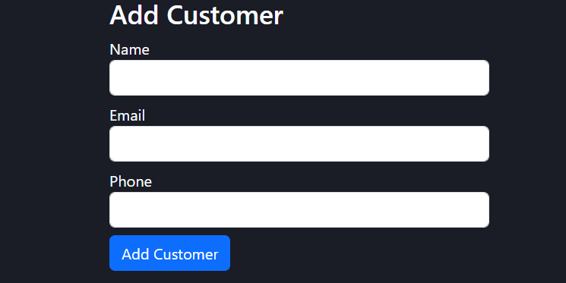
Add Product Page:
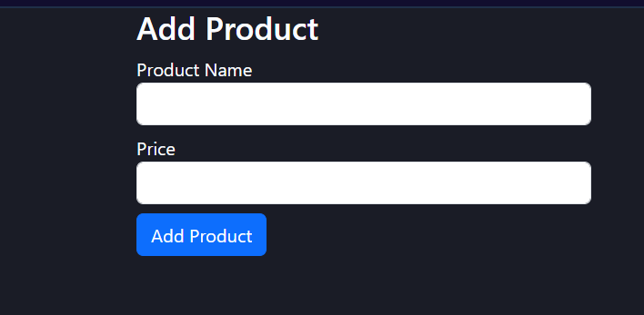

Add Invoice Page:
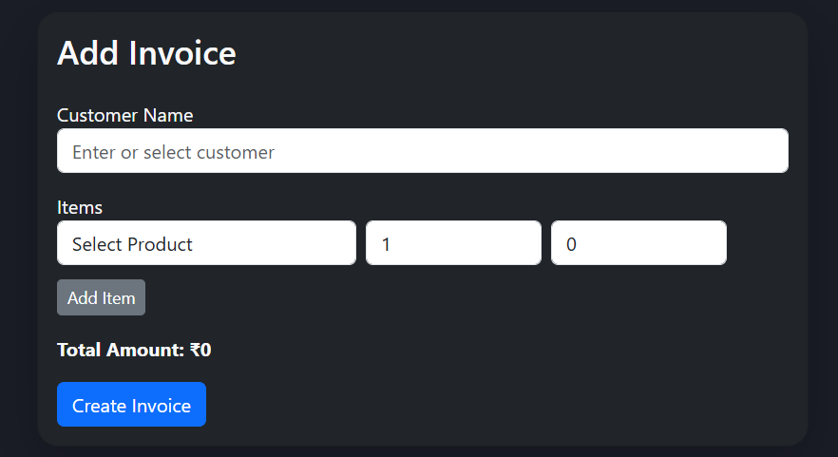

Email Invoice Page:
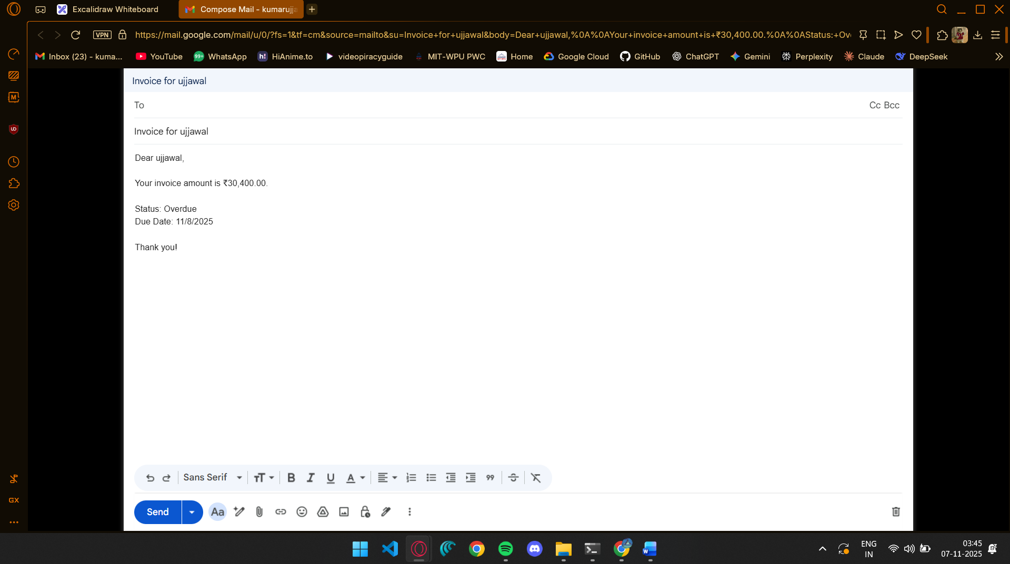

Delete Invoice Popup:
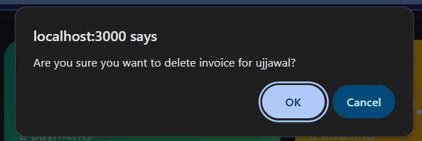

API Testing using Postman:
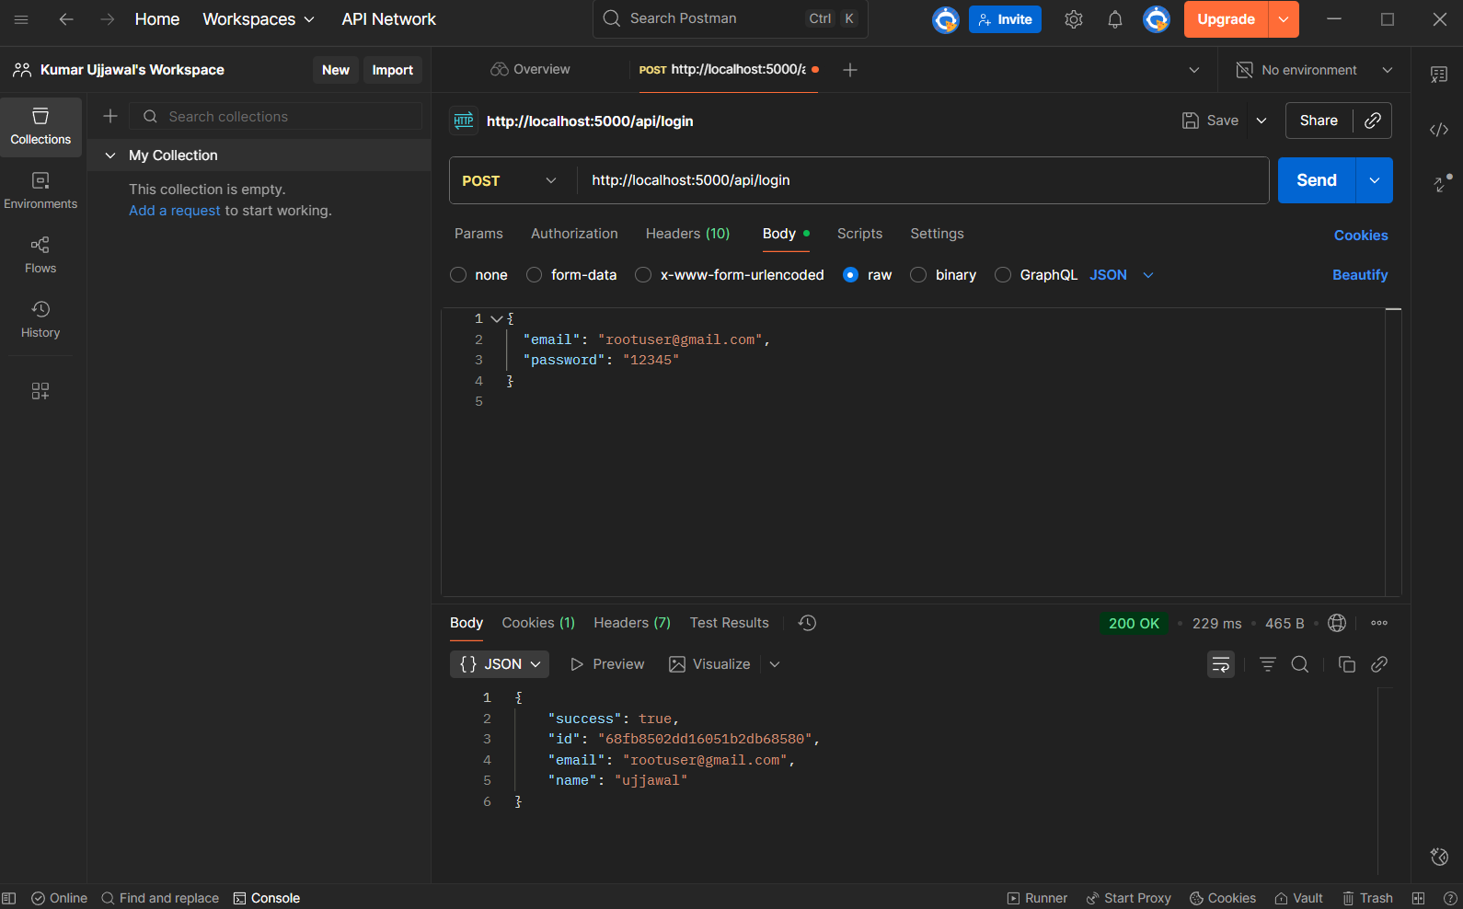

Conclusion:
The Invoice Management System achieves its goal of automating invoice creation and management for small businesses and freelancers. It offers a simple yet powerful platform for handling financial records, minimizing human errors, and increasing operational efficiency. The project demonstrates the effectiveness of React–Flask–MongoDB integration in building modular and scalable business applications. Future improvements will focus on advanced analytics and revenue forecasting, mobile and cloud integration, and enhanced user role management with multi-language support.
Overall, this work represents a step forward in digitizing financial processes for small-scale enterprises, making technology-driven accounting accessible to all.

References:
[1] “Zoho Invoice.” Accessed: Oct. 31, 2025. [Online]. Available: https://www.zoho.com/invoice/
[2] “QuickBooks.” Accessed: Oct. 31, 2025. [Online]. Available: https://quickbooks.intuit.com/in/
[3] “Tally ERP.” Accessed: Oct. 31, 2025. [Online]. Available: https://tallysolutions.com
[4] “ReactJS Documentation.” Accessed: Oct. 31, 2025. [Online]. Available: https://react.dev/
[5] “Flask Documentation.” Accessed: Oct. 31, 2025. [Online]. Available: https://flask.palletsprojects.com/
[6] “MongoDB Documentation.” Accessed: Oct. 31, 2025. [Online]. Available: https://www.mongodb.com/docs/
[7] “Guide to Technical Report Writing.” The IET. Accessed: Oct. 31, 2025.
[8] “Sample Technical Report.” Scribd. Accessed: Oct. 31, 2025.

